Now we are going talk about how to make a responsive with the help of flex and now teacher shows us the output we get after code as shown below

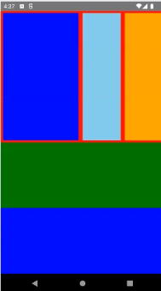

Now there are two-three reason see go though the full lesson to know about it

This is because from styling point of view in React native is very important and why it is important

Whenever we make an application always try that you’re app is responsive in nature and you will learn about how to make it in this lesson if you see it properly and whole lesson

Now question may arise what is responsive Now your mobile might be in any size weather it is 5 inches , 6 inches or even if it is tablet your application should be visible. In side and in upper and lower part there should be no space. Text, input should not be cut by the edges of the screen. We call it responsive UI do that whatever may be the size of the device our layout become flexible. Now how we will believe that the UI you make is flexible and it is responsive because for now. There is only one screen size open. So we will make it landscape by clicking on the marked button

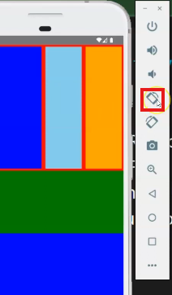

After rotating to landscape will look like below

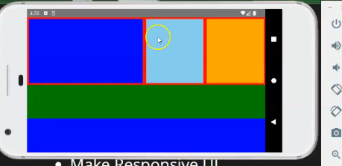

Now you can see our colored section are changed automatically but still there is no scroll and space nothing is cut by screen edge

There was three boxes in vertical and three boxes still in landscape view

But in landscape the upper boxes are bigger than the boxes in the portrait

Now as we make it portrait then it will again look like it was looking in portrait si we call it responsive UI It is not like we have taken two screen size like creating styles for portrait and then style for landscape. It is not like this it all is the work of flex. Now we come in code

Even On responsive UI one or two lessons are coming in which we will take text, Button and How to make them small and bigger. We will see in different screen size. But how to make Layout and how boxes work and how spaces between them is managed you will definitely learn it in this lesson. And from the point of view of Interview question this is an important lesson because obviously we are talking about flex and responsive UI. Even they could ask you meaning of Responsive Layout

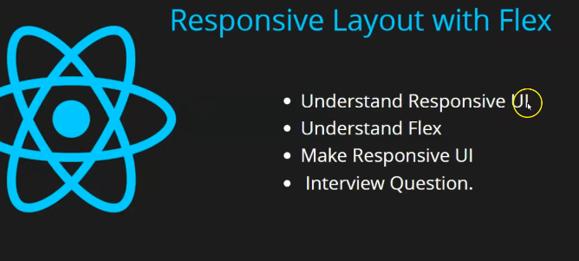

First of all we will understand responsive layout which teacher have already told us that what actually is this and then we will understand flex we will start with code and then we will make a responsive UI same as Teacher that was shown by him to us. We will make it and then we will make it and then we will discuss Interview question

Now teacher from start is making an Now in his initial UI it is written Responsive UI with Flex



So can we make responsive UI without flex so course you can make it.

3:00

If you have work in website development then we can give height and width in percentage so by giving percentage you can create a responsive UI problem with that it is very consuming and if there is lots od screen size means the screen size is very small and we start making for tablet then you might need media query (who knows) or for different layout you might need to write different code which is not that good and nowadays in website flex is used. So we go with flex. It is a good approach it is nor like that Teacher is saying it for the sake of his lesson profession the people who make responsive things like in React native or web development flex is used there yes you can see flex in web as well. It is not exact same but also almost same. So we first understand how flex work so first thing to apply it is use flex which is a property and you have to give value to it. you can give value 1,2 or 3. So what does it mean Now we may apply it but how it works. Suppose you have two box and you give one box flex :1 and also give other box as flex 1. Now you will say tell the definition don’t tell it directly. Teacher will tell us even by this direct way you will understand it easily. Now back to the topic you give ach box a flex of 1. So what will happen is that 50 percent upper screen will be taken by one box. And 50 percent screen will be taken by another box suppose we add two views then 50 percent will be taken by one view and 50 percent will be taken by another view.

It divide the views according to the ratio Now suppose we make a view (and there is a text flex 1 )inside another parent View and remove the text and again add another view (and there is a text flex 2)inside parent node now we add a View again .Now each view will take percent of the screen look Now our code will look like below.

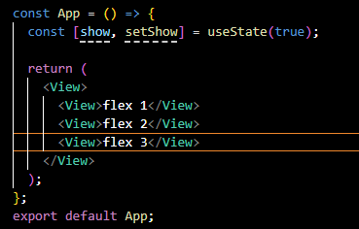

And if we add another view now there are four views inside parent view now this time each will take 25 percent of the screen.

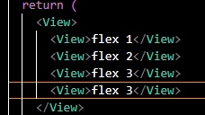

( Beware the code is for demonstration as text should always be in between Text component )

The space flex get it takes that space and grab that space now suppose in the last View the flex is removed then in first three have flex leaving the last View element Now how much space three will take leave it now suppose we have two view inside parent view one have flex and another have don’t but it have a static size of 100 pixel. Now how much upper view will take it

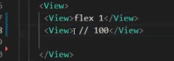

Then the whole upper screen will be taken by the flex but leave 100 pixel from bottom for the second flex. When e apply flex then that div or component whatever space it get it grabs it with respect to another flex and non flex element(who knows).

Flex is not always 1 it works for 2 as well Now Suppose we give one View as flex1 and another view as flex 2 as shown below for demonstration

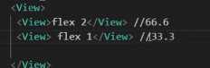

Now the upper view will take 66 percent and the lower that has flex 1 will take 33.3 percent

So flex 2 has doubled ratio so the ratio is maintained(who knows) what if we had taken flex 3 in place of flex 2 as shown below

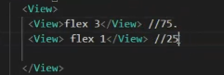

then Flex 3 View should take 75 percent and bottom flex will take 25 percent Now teacher will teach us practical so that you can understand it properly So first of all if you want to add flex best thing is that give the parent view as flex

suppose we start from start in UI and just place one View this time and we add background color to it as shown in the code below in the code

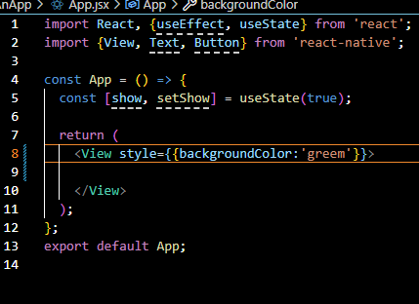

Now in UI you can see the screen is blank now as shown below



And now we give this View as flex : 1 as shown in the code below

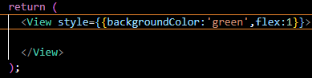

Now you can see the output it is green in color as shown below



It takes the full screen because all area is available for it to grab. And it does not have any other element with it in its equal heirarchy.

7:34

So whenever you want to add flex to the internal element you need to add it to the external elements covering it (who knows) Now we need another View inside the external View

I think we need to give flex in outer component then only flex will properly work in internal elements (according to the Teacher).

So now we add flex and style to the internal component as marked below

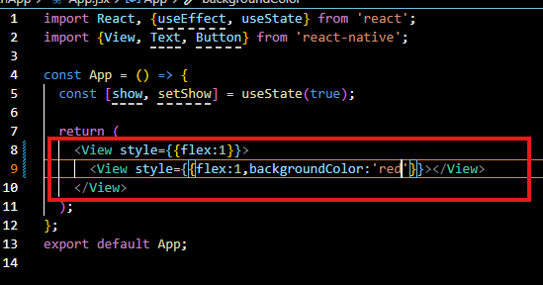

Now our output will look like below



So internal view covers all the space taken by the external view that is whole screen as it was already flex Now we take another internal view we also give it flex of 1 and give it the color of green

Now our code will be like below

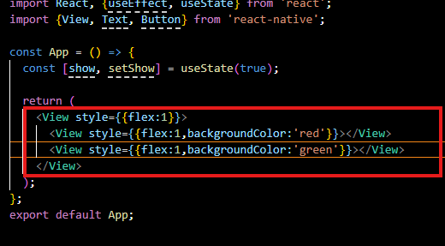

Now our output will be like below



Now it divide the screen into 50-50 percent Now interesting thing is we add another internal view having flex as 1 and background as blue

**Code:-**

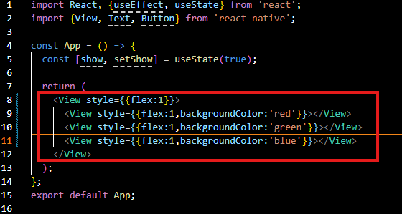

**Output:-**



Now each internal components covers 33 percent of the screen

We add another fourth internal component now

**Code:-**

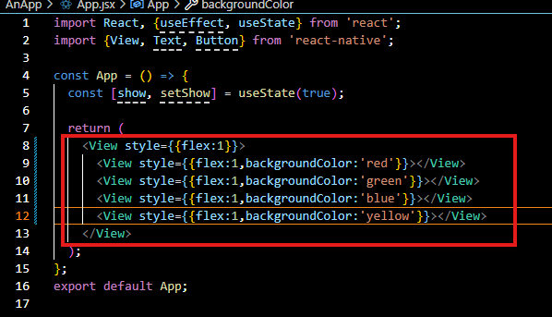

**Output:-**



Now you can see it is divided into 4 equal parts as shown above .Now you give flex and then corresponding to it later whatever flex comes it takes equal ratio there with other flex .If you even make the screen landscape by tilting it then still it will work as shown below

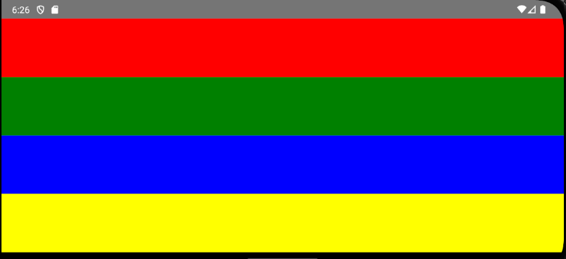

We will code more now and will see it later .Instead of four Teacher prefer three internal elements .Now suppose you want to give more area to the first component from top to Bottom in the external component So you set the first component flex from 1 to 2 as marked below

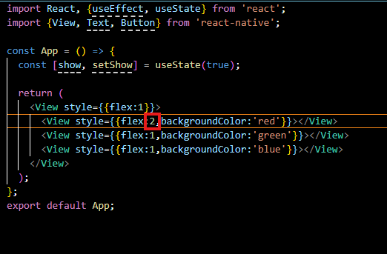

Now our output will be like below



So now first component will take double as compared to its previous flex:1

So first component will take 50 percent and the second and third will take 25 percent of the outer view we are doing style in each component so we use StyleSheet for internal CSS. Now import style sheet



So we add the “main” property to the new formed Stylesheet and in main we set the main to property of flex:1

Now we add another property that is box1 ( that will be used for first internal view component of external view component ) and it contains flex of 1 and background color of red. we add another property that is box2 ( that will be used for second internal view component of external view component ) and it contains flex of 1 and background color of blue and we add another property that is box3 ( that will be used for third internal view component of external view component ) and it contains flex of 1 and background color of green

**Code:-**

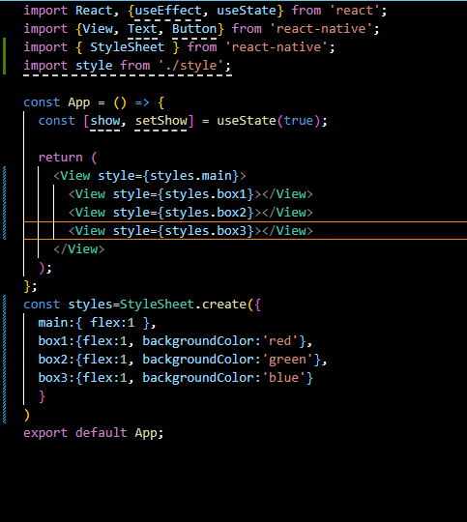

Now our output will be same as it was before



Now you think one thing that can we change it as by default it is taking like a column (that is elements are coming from top to bottom) can we change it to row( It means the element is going from top left to right ) if you add the style property flexDirection and set it to row value to the outer component that is modify the main property of styles as shown below

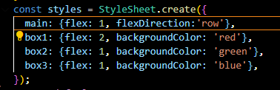

Now our output will be like below

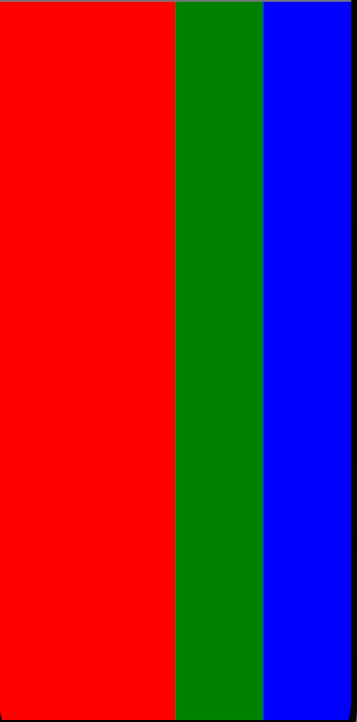

Now there direction is changed from top to bottom is column and from left to right is row

12:10

Previously it was column that is from top to bottom but now it is from left to right that is our row but Teacher want that it should be like it was before

Now you want that there should be dome more boxes inside box 1 so you make another view inside box1 view and then it will be an innerbox within box1 we add innerBox1 Stylesheet property here which we will declare later Now this innerBox wil have three boxes inside like its outer boxes

But they should be left to right unlike outer boxes

So we now we define our InnerBox1 styles such that we give it flex 1 and background color skyblue Now our innerBox1 design code will look as marked below

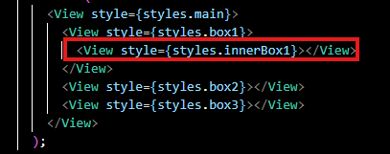

And in style innerBox1 will look like below

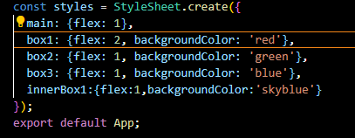

Now our output will look like



We can see it that innerBox has covered the box1 fully as innerbox has sky blue color and but the box1 had red color but we want margin in the innerbox1 we give it margin of 10 so that you can know it is an inner box Now you can see it that it is an innerbox of box1

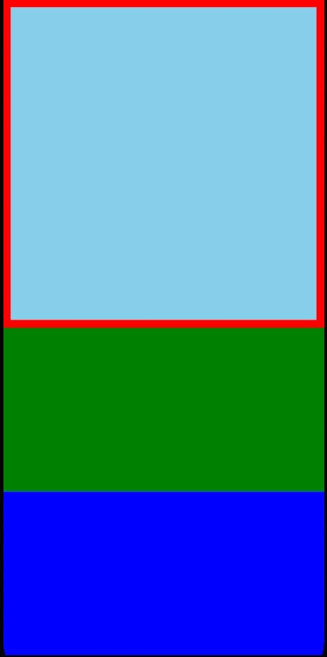

Now in our output you can see that red is of outer box that this box1 and the skyblue is of innerbox.

But we wanted three boxes inside the box1 so we duplicate innerbox two times our innerbox of box1 design code looks like below

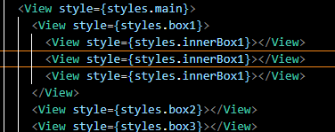

Now our output will look like below

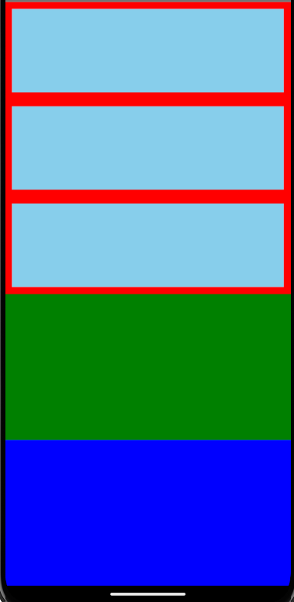

But we wanted innerboxes from left to right now the parent box of innerboxes is box1 and in parent boxes we write direction of the boxes inside it

So in style box 1 property we make the flex direction is row as shown in the marked style code snippets

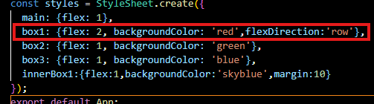

Now our output will look like below

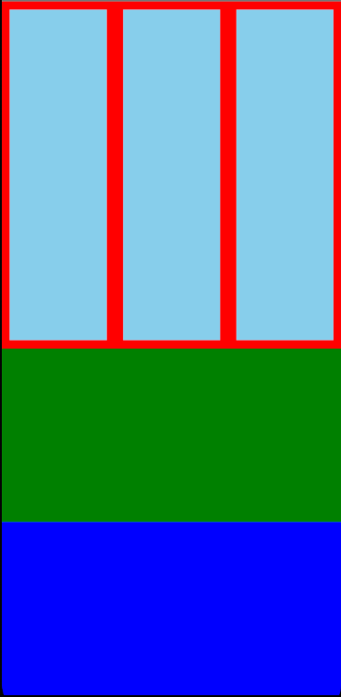

Now we want that there color should be different color to each innerboxes so we give the second innerbox style that is innerbox2 and third innerbox as innerBox3 as shown below in the design code snippets

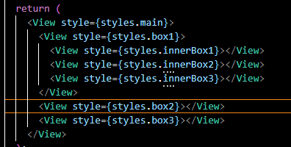

Now we declare style properties for innerbox2 and innerbox3 as shown in the styles snippets

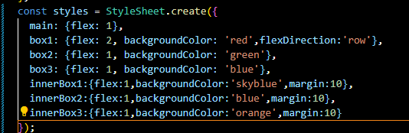

Now our output will look like below

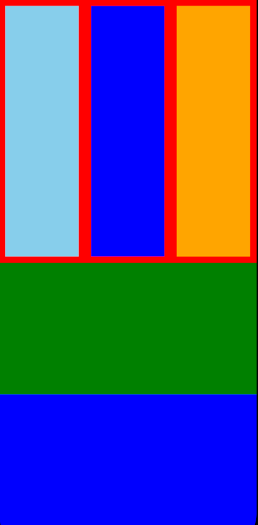

If you want ot toggle margin then you can do so Now you can see hoe to make the boxes bigger smaller (maybe inner)

Even if you have given height and width in percentage it would have been worked but it is old way to make dynamic design(who knows the context) If we make the phone in landscape mode then it looks like below working perfectly fine

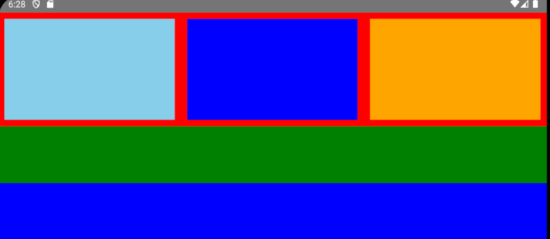

Now you can see it any screen size Has we given height and width to anything in the design code Now if we have not given height and width then that means it is flexing automatically according to the whatever space the boxes get.

SO now in next lesson we will write some content here so that we can add some header and footer here not more but we will do the way we can do in web page to make it responsive by adding buttons and all here So that’s all for this lesson. See you in next lesson